Prism-Based Composite Solids

Definition
# Source: AI Source: Provided by: [Data Path: Persons Table -> ID Column: 1, Name_En Column: Motasem Essam] -> From: [ChatGPT] on [7/25/2026]
Prism-Based Composite Solids with Flat and Curved Surfaces are three-dimensional geometric objects formed by joining a prism with one or more solids that have curved surfaces, such as cylinders, cones, spheres, or hemispheres.
The resulting composite solid contains both:
- Flat surfaces: Polygonal faces inherited from the prism and any exposed planar faces of the other components.
- Curved surfaces: Cylindrical, conical, spherical, or other curved surfaces contributed by the attached components.
The components may be joined through complete faces, partial face contact, or other suitable connecting regions.

Simple Definition
# Source: AI Source: Provided by: [Data Path: Persons Table -> ID Column: 1, Name_En Column: Motasem Essam] -> From: [ChatGPT] on [7/25/2026]
A Prism-Based Composite Solid with Flat and Curved Surfaces is a solid formed by combining a prism with one or more curved solids.
Example: A rectangular prism with a cylinder attached to its top face.

Geometric Representation
# Source: AI Source: Provided by: [Data Path: Persons Table -> ID Column: 1, Name_En Column: Motasem Essam] -> From: [ChatGPT] on [7/25/2026]
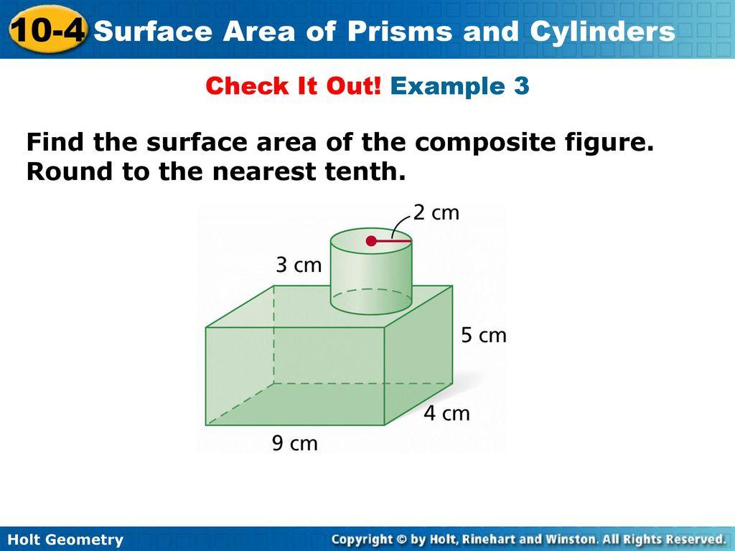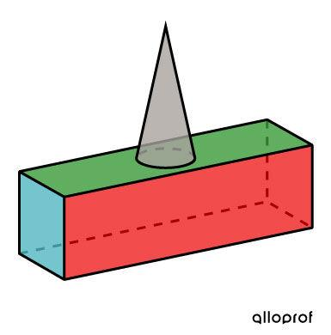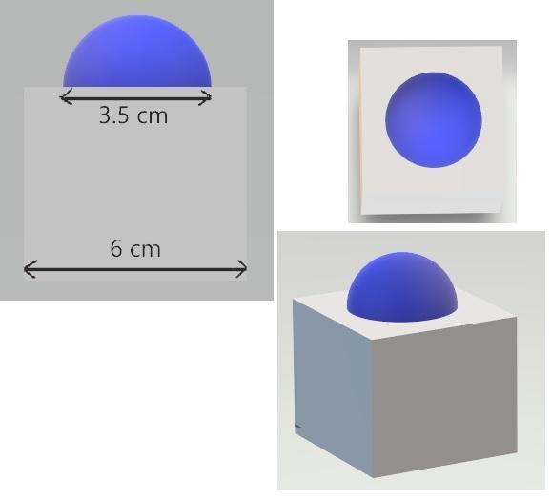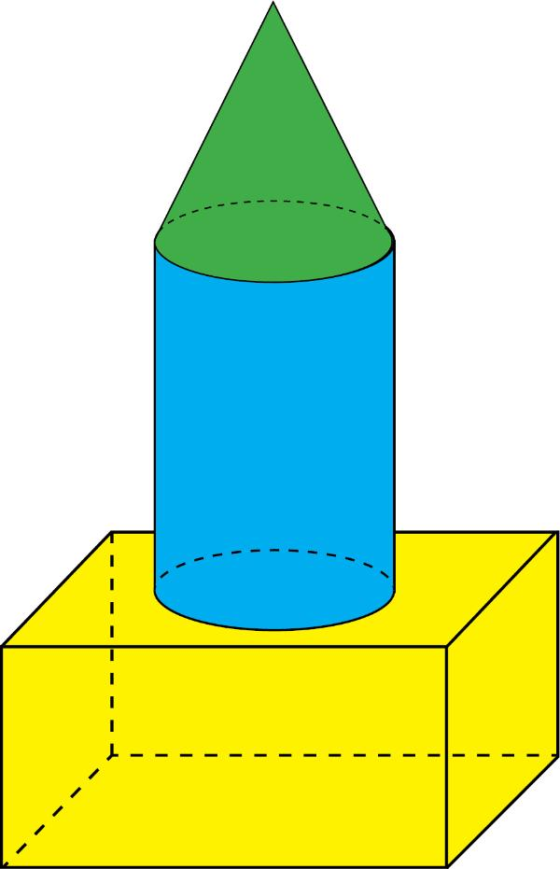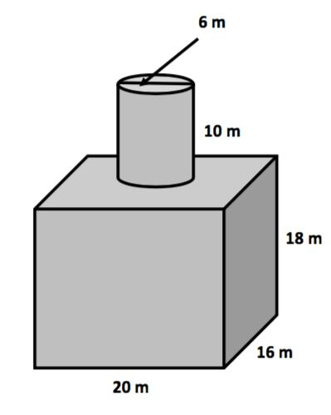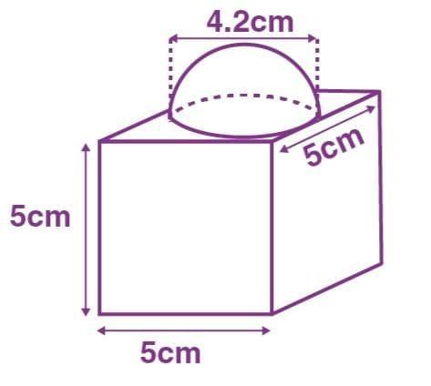
Main Components
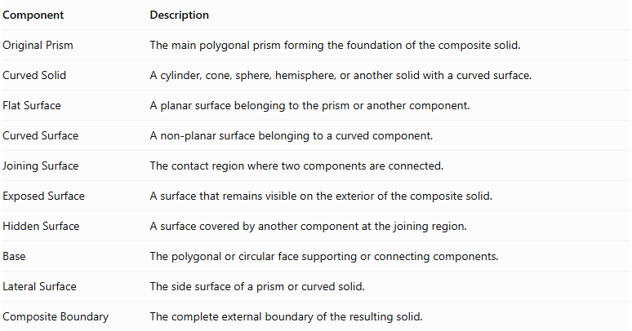
Component | Description
Original Prism | The main polygonal prism forming the foundation of the composite solid.
Curved Solid | A cylinder, cone, sphere, hemisphere, or another solid with a curved surface.
Flat Surface | A planar surface belonging to the prism or another component.
Curved Surface | A non-planar surface belonging to a curved component.
Joining Surface | The contact region where two components are connected.
Exposed Surface | A surface that remains visible on the exterior of the composite solid.
Hidden Surface | A surface covered by another component at the joining region.
Base | The polygonal or circular face supporting or connecting components.
Lateral Surface | The side surface of a prism or curved solid.
Composite Boundary | The complete external boundary of the resulting solid.

Types of Prism-Based Composite Solids with Flat and Curved Surfaces

Prism-Cylinder Composite Solids
# Source: AI Source: Provided by: [Data Path: Persons Table -> ID Column: 1, Name_En Column: Motasem Essam] -> From: [ChatGPT] on [7/25/2026]
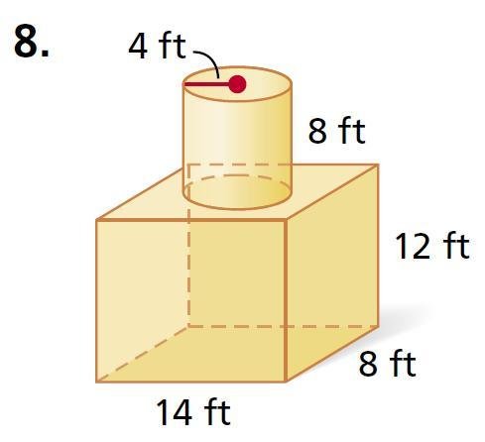
A prism is joined with one or more cylinders, creating a solid with polygonal flat faces and cylindrical curved surfaces.
Examples:
- Rectangular prism with a cylinder on top.
- Rectangular prism with a cylinder attached to its side.
- Square prism with multiple cylinders.
- Triangular prism with a cylinder attached to a lateral face.
- Hexagonal prism with a cylinder on top.
- Prism with stacked cylinders.
- Prism with coaxial cylindrical components.

Prism-Cone Composite Solids
# Source: AI Source: Provided by: [Data Path: Persons Table -> ID Column: 1, Name_En Column: Motasem Essam] -> From: [ChatGPT] on [7/25/2026]
A prism is joined with one or more cones, producing a solid with polygonal flat faces and conical curved surfaces.
Examples:
- Rectangular prism with a cone on top.
- Square prism with a cone attached to its base.
- Triangular prism with a cone attached to a lateral face.
- Prism with multiple cones.
- Prism with stacked cone and cylinder components.
- Prism with an inverted cone attached underneath.

Prism-Sphere Composite Solids
# Source: AI Source: Provided by: [Data Path: Persons Table -> ID Column: 1, Name_En Column: Motasem Essam] -> From: [ChatGPT] on [7/25/2026]
A prism is combined with one or more spheres, creating a solid with flat polygonal faces and spherical curved surfaces.
Examples:
- Rectangular prism with a sphere on top.
- Square prism with a sphere attached to a side.
- Triangular prism with a sphere attached to a lateral face.
- Prism with multiple spheres.
- Prism with partially embedded spheres.
- Prism with spherical components attached to different faces.

Prism-Hemisphere Composite Solids
# Source: AI Source: Provided by: [Data Path: Persons Table -> ID Column: 1, Name_En Column: Motasem Essam] -> From: [ChatGPT] on [7/25/2026]
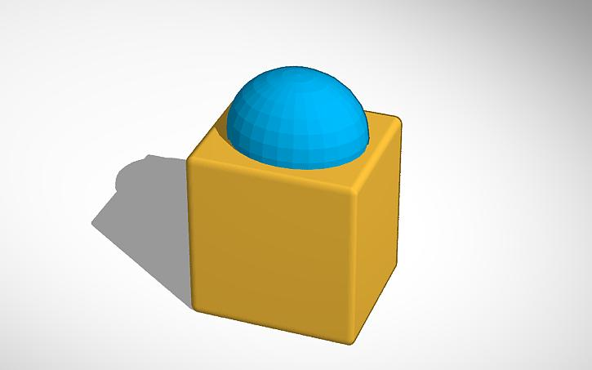
A prism is joined with one or more hemispheres, producing a solid with flat polygonal surfaces and hemispherical curved surfaces.
Examples:
- Rectangular prism with a hemisphere on top.
- Square prism with hemispheres attached to opposite faces.
- Triangular prism with a hemisphere attached to a lateral face.
- Prism with multiple hemispherical components.
- Prism with a hemisphere attached underneath.
- Prism with hemispheres attached to different faces.

Prism-Frustum Composite Solids
# Source: AI Source: Provided by: [Data Path: Persons Table -> ID Column: 1, Name_En Column: Motasem Essam] -> From: [ChatGPT] on [7/25/2026]
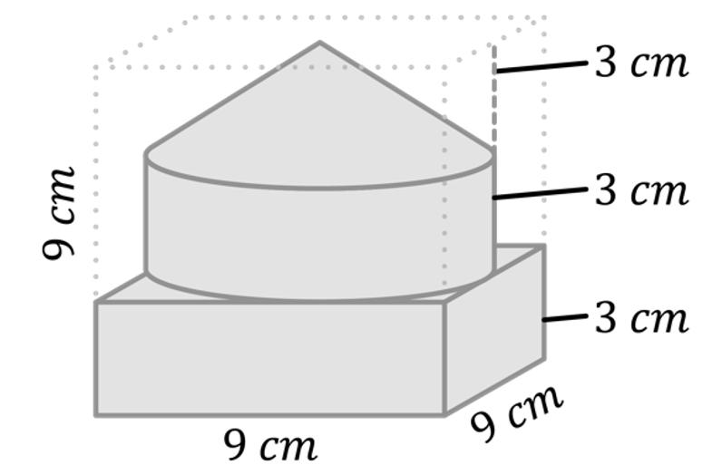
A prism is combined with a frustum, creating a solid with flat polygonal surfaces and a curved or sloping lateral surface.
Examples:
- Rectangular prism with a conical frustum on top.
- Square prism with a conical frustum attached underneath.
- Triangular prism with a conical frustum attached to a side.
- Prism with multiple conical frustums.
- Prism with a frustum connected to a cylinder.

Prism with Multiple Curved-Solid Types
# Source: AI Source: Provided by: [Data Path: Persons Table -> ID Column: 1, Name_En Column: Motasem Essam] -> From: [ChatGPT] on [7/25/2026]
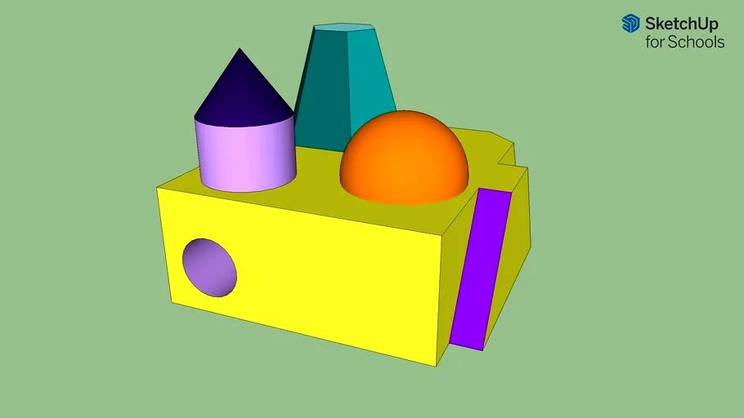
A prism is combined with two or more different types of curved solids.
Examples:
- Prism with a cylinder and a hemisphere.
- Prism with a cylinder and a cone.
- Prism with a cone and a sphere.
- Prism with a cylinder, cone, and hemisphere.
- Prism with multiple cylinders and spheres.
- Prism with several different curved components.

Classification by Prism Type
# Source: AI Source: Provided by: [Data Path: Persons Table -> ID Column: 1, Name_En Column: Motasem Essam] -> From: [ChatGPT] on [7/25/2026]
The composite solid can also be classified according to the type of prism used as its main component.
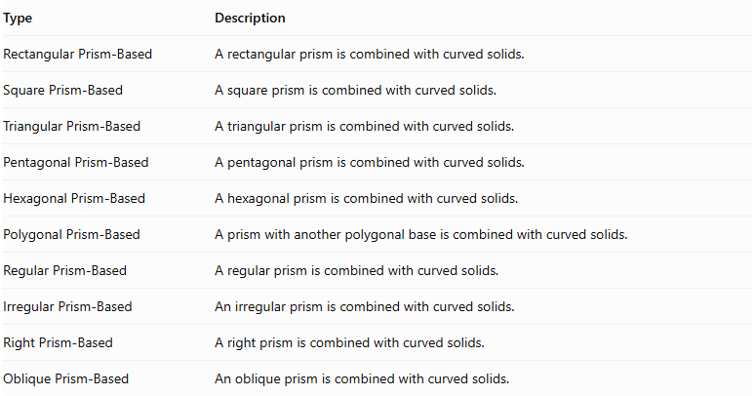
Type | Description
Rectangular Prism-Based | A rectangular prism is combined with curved solids.
Square Prism-Based | A square prism is combined with curved solids.
Triangular Prism-Based | A triangular prism is combined with curved solids.
Pentagonal Prism-Based | A pentagonal prism is combined with curved solids.
Hexagonal Prism-Based | A hexagonal prism is combined with curved solids.
Polygonal Prism-Based | A prism with another polygonal base is combined with curved solids.
Regular Prism-Based | A regular prism is combined with curved solids.
Irregular Prism-Based | An irregular prism is combined with curved solids.
Right Prism-Based | A right prism is combined with curved solids.
Oblique Prism-Based | An oblique prism is combined with curved solids.

Classification by Arrangement
# Source: AI Source: Provided by: [Data Path: Persons Table -> ID Column: 1, Name_En Column: Motasem Essam] -> From: [ChatGPT] on [7/25/2026]
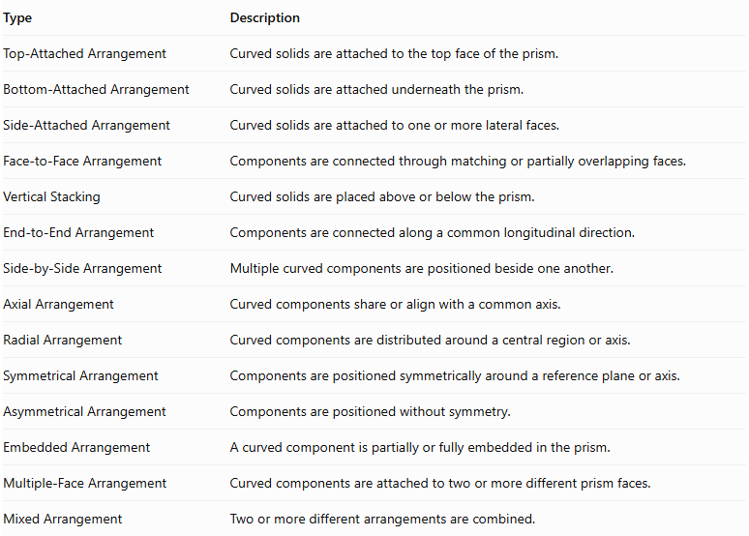
Type | Description
Top-Attached Arrangement | Curved solids are attached to the top face of the prism.
Bottom-Attached Arrangement | Curved solids are attached underneath the prism.
Side-Attached Arrangement | Curved solids are attached to one or more lateral faces.
Face-to-Face Arrangement | Components are connected through matching or partially overlapping faces.
Vertical Stacking | Curved solids are placed above or below the prism.
End-to-End Arrangement | Components are connected along a common longitudinal direction.
Side-by-Side Arrangement | Multiple curved components are positioned beside one another.
Axial Arrangement | Curved components share or align with a common axis.
Radial Arrangement | Curved components are distributed around a central region or axis.
Symmetrical Arrangement | Components are positioned symmetrically around a reference plane or axis.
Asymmetrical Arrangement | Components are positioned without symmetry.
Embedded Arrangement | A curved component is partially or fully embedded in the prism.
Multiple-Face Arrangement | Curved components are attached to two or more different prism faces.
Mixed Arrangement | Two or more different arrangements are combined.

Classification by Surface Combination
# Source: AI Source: Provided by: [Data Path: Persons Table -> ID Column: 1, Name_En Column: Motasem Essam] -> From: [ChatGPT] on [7/25/2026]
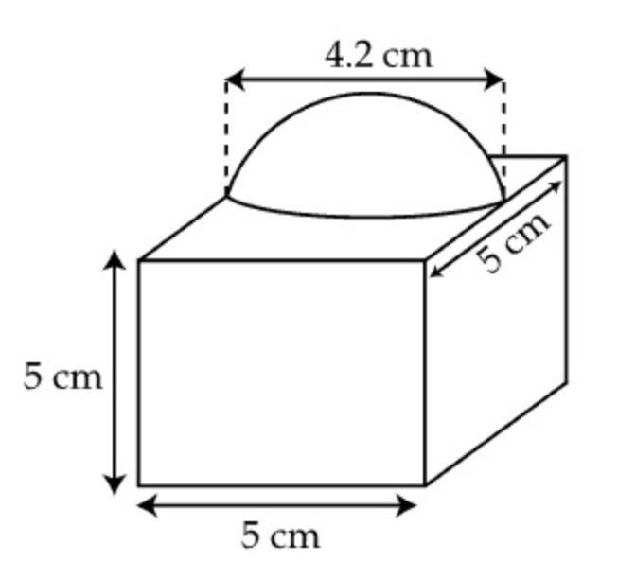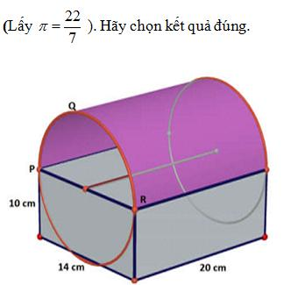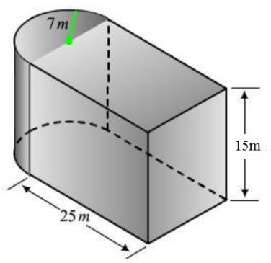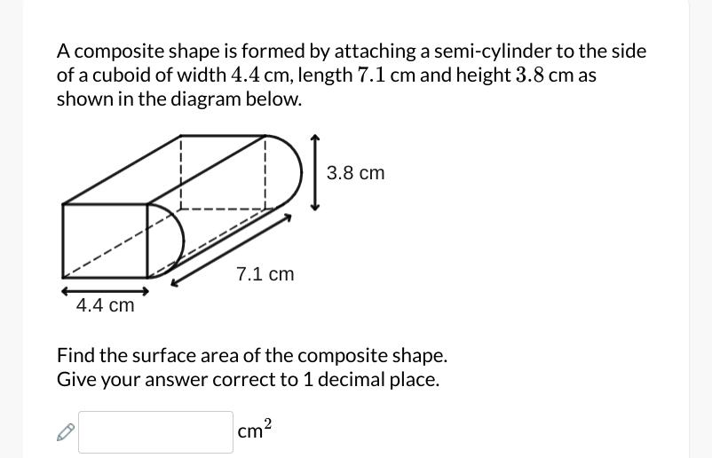
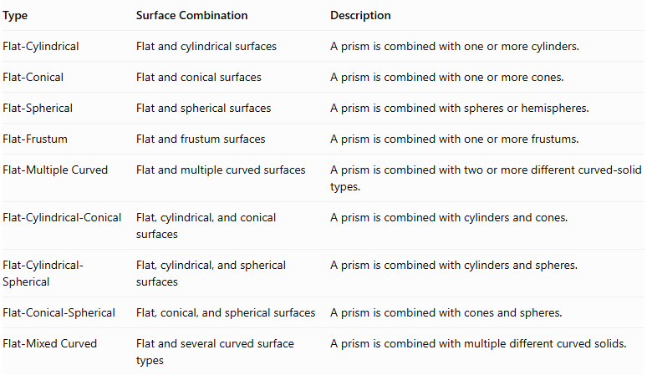
Type | Surface Combination | Description
Flat-Cylindrical | Flat and cylindrical surfaces | A prism is combined with one or more cylinders.
Flat-Conical | Flat and conical surfaces | A prism is combined with one or more cones.
Flat-Spherical | Flat and spherical surfaces | A prism is combined with spheres or hemispheres.
Flat-Frustum | Flat and frustum surfaces | A prism is combined with one or more frustums.
Flat-Multiple Curved | Flat and multiple curved surfaces | A prism is combined with two or more different curved-solid types.
Flat-Cylindrical-Conical | Flat, cylindrical, and conical surfaces | A prism is combined with cylinders and cones.
Flat-Cylindrical-Spherical | Flat, cylindrical, and spherical surfaces | A prism is combined with cylinders and spheres.
Flat-Conical-Spherical | Flat, conical, and spherical surfaces | A prism is combined with cones and spheres.
Flat-Mixed Curved | Flat and several curved surface types | A prism is combined with multiple different curved solids.

Mathematical Properties and Formulas

Volume of a Prism-Based Composite Solid
# Source: AI Source: Provided by: [Data Path: Persons Table -> ID Column: 1, Name_En Column: Motasem Essam] -> From: [ChatGPT] on [7/25/2026]
The general formula is:
$$V_{composite}=V_{prism}+\sum_{i=1}^{n}{V_{i}}$$
Where:
- $V_{prism}$ = volume of the original prism.
- $V_{i}$ = volume of each attached curved solid.
- $n$ = number of attached curved components.
For non-overlapping components:
$$V_{prism}=BH$$
Where:
- $B$ = area of the prism's base.
- $H$ = perpendicular distance between its bases.

Volume Formulas of Common Components
# Source: AI Source: Provided by: [Data Path: Persons Table -> ID Column: 1, Name_En Column: Motasem Essam] -> From: [ChatGPT] on [7/25/2026]
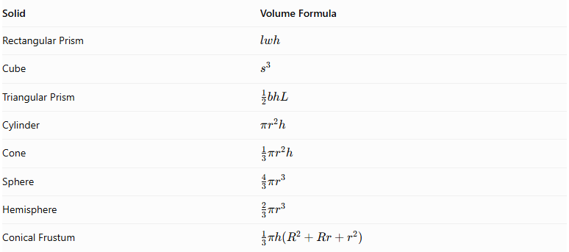
Solid | Volume Formula
Rectangular Prism | $$lwh$$
Cube | $$s^{3}$$
Triangular Prism | $$\frac{1}{2}bhL$$
Cylinder | $$πr^{2}h$$
Cone | $$\frac{1}{3}πr^{2}h$$
Sphere | $$\frac{4}{3}πr^{3}$$
Hemisphere | $$\frac{2}{3}πr^{3}$$
Conical Frustum | $$\frac{1}{3}πh(R^{2}+Rr+r^{2})$$

External Surface Area
# Source: AI Source: Provided by: [Data Path: Persons Table -> ID Column: 1, Name_En Column: Motasem Essam] -> From: [ChatGPT] on [7/25/2026]
The external surface area is calculated using only the surfaces exposed on the outside of the composite solid.
For two components joined through a complete matching planar interface:
$${SA}_{composite}={SA}_{1}+{SA}_{2}-2A_{joining}$$
Where:
- ${SA}_{1}$ = total surface area of the first component.
- ${SA}_{2}$ = total surface area of the second component.
- $A_{joining}$ = area of the hidden joining interface.
For multiple components with separate, non-overlapping planar joining interfaces:
$${SA}_{composite}=\sum{{SA}_{i}}-2\sum{A_{joining}}$$
This simplified formula assumes that each joining interface is a complete planar contact region and that no other intersections alter the external boundary. For partial or curved intersections, calculate the actual exposed surfaces.

Common Curved Surface Area Formulas
# Source: AI Source: Provided by: [Data Path: Persons Table -> ID Column: 1, Name_En Column: Motasem Essam] -> From: [ChatGPT] on [7/25/2026]
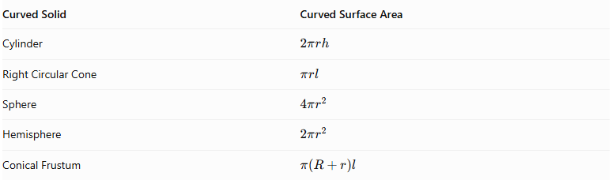
Curved Solid | Curved Surface Area
Cylinder | $$2πrh$$
Right Circular Cone | $$πrl$$
Sphere | $$4πr^{2}$$
Hemisphere | $$2πr^{2}$$
Conical Frustum | $$π(R+r)l$$
For a right circular cone:
$$l=\sqrt{r^{2}+h^{2}}$$
For a conical frustum:
$$l=\sqrt{h^{2}+(R-r)^{2}}$$

Important Surface-Area Considerations
# Source: AI Source: Provided by: [Data Path: Persons Table -> ID Column: 1, Name_En Column: Motasem Essam] -> From: [ChatGPT] on [7/25/2026]
- A circular base attached to a prism becomes hidden and must not be counted as an external surface.
- A hemisphere attached through its flat circular base contributes only its curved hemispherical surface.
- A cone attached through its circular base contributes only its curved lateral surface.
- A cylinder attached through one circular base contributes its curved lateral surface and its other exposed circular base.
- A sphere attached at a single point has no finite-area joining face, so its entire spherical surface remains exposed in the ideal mathematical model.
- If the curved component intersects a prism partially, only the actual exposed portions should be included.

Worked Examples

Example 1: Rectangular Prism with a Cylinder on Top
# Source: AI Source: Provided by: [Data Path: Persons Table -> ID Column: 1, Name_En Column: Motasem Essam] -> From: [ChatGPT] on [7/25/2026]
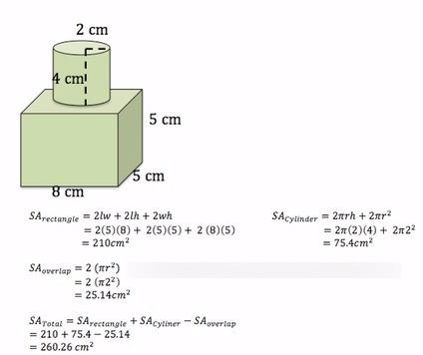
Given:
Rectangular prism:
- Length: $L=10 cm$
- Width: $W=8 cm$
- Height: $H=4 cm$
Attached cylinder:
- Radius: $r=2 cm$
- Height: $h=5 cm$
The cylinder is centered on the top face, and its entire circular base lies within the rectangular face.
Step 1: Calculate the prism volume.
$$V_{prism}=LWH$$
$$V_{prism}=10(8)(4)=320{ cm}^{3}$$
Step 2: Calculate the cylinder volume.
$$V_{cylinder}=πr^{2}h$$
$$V_{cylinder}=π(2)^{2}(5)=20π$$
Step 3: Calculate the total volume.
$$V_{composite}=320+20π$$
$$\boxed{V_{composite}≈382.83{ cm}^{3}}$$
Step 4: Calculate the prism surface area.
$${SA}_{prism}=2(LW+LH+WH)$$
$$=2(80+40+32)=304{ cm}^{2}$$
Step 5: Calculate the cylinder surface area.
$${SA}_{cylinder}=2πr^{2}+2πrh$$
$$=2π(2)^{2}+2π(2)(5)$$
$$=28π$$
Step 6: Remove the hidden joining surfaces.
The cylinder's bottom circular face and the covered circular region on the prism's top face are hidden.
$$A_{joining}=π(2)^{2}=4π$$
$${SA}_{composite}=304+28π-2(4π)$$
$$=304+20π$$
$$\boxed{{SA}_{composite}≈366.83{ cm}^{2}}$$
Conclusion: The composite solid has a rectangular prism as its main component and a cylinder attached to its top. Its exterior contains flat rectangular surfaces and a curved cylindrical surface.

Example 2: Square Prism with a Cone on Top
# Source: AI Source: Provided by: [Data Path: Persons Table -> ID Column: 1, Name_En Column: Motasem Essam] -> From: [ChatGPT] on [7/25/2026]
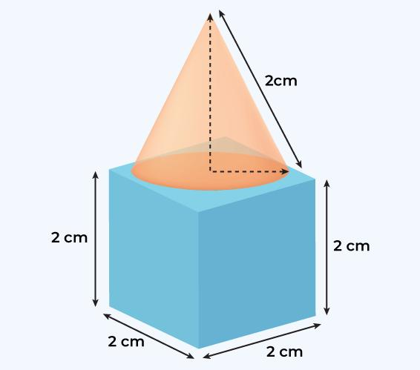
Given:
Square prism:
- Base side: $s=8 cm$
- Height: $H=6 cm$
Attached cone:
- Radius: $r=2 cm$
- Perpendicular height: $h=3 cm$
The cone is centered on the top square face, and its circular base lies entirely within that face.
Step 1: Calculate the prism volume.
$$V_{prism}=s^{2}H$$
$$V_{prism}=8^{2}(6)=384{ cm}^{3}$$
Step 2: Calculate the cone volume.
$$V_{cone}=\frac{1}{3}πr^{2}h$$
$$=\frac{1}{3}π(2)^{2}(3)=4π{ cm}^{3}$$
Step 3: Calculate the total volume.
$$V_{composite}=384+4π$$
$$\boxed{V_{composite}≈396.57{ cm}^{3}}$$
Step 4: Calculate the prism surface area.
$${SA}_{prism}=2s^{2}+4sH$$
$$=2(8^{2})+4(8)(6)$$
$$=128+192=320{ cm}^{2}$$
Step 5: Calculate the cone slant height.
$$l=\sqrt{r^{2}+h^{2}}$$
$$l=\sqrt{2^{2}+3^{2}}=\sqrt{13}$$
Step 6: Calculate the cone lateral surface area.
$${LSA}_{cone}=πrl$$
$$=2π\sqrt{13}$$
Step 7: Remove the hidden joining surfaces.
The cone's circular base and the corresponding covered region of the prism are hidden.
$$A_{joining}=π(2)^{2}=4π$$
Therefore:
$${SA}_{composite}=320-4π+2π\sqrt{13}$$
$$\boxed{{SA}_{composite}≈330.09{ cm}^{2}}$$
Conclusion: The square prism and cone form a composite solid with flat square and rectangular surfaces and a curved conical surface.

Important Characteristics
# Source: AI Source: Provided by: [Data Path: Persons Table -> ID Column: 1, Name_En Column: Motasem Essam] -> From: [ChatGPT] on [7/25/2026]
- Prism-Based Structure: The prism forms the main component of the composite solid.
- Mixed Surface Types: The resulting solid contains both flat and curved external surfaces.
- Multiple Curved Components: One or more cylinders, cones, spheres, hemispheres, or frustums may be attached.
- Different Prism Bases: The main prism may have triangular, rectangular, square, pentagonal, hexagonal, or other polygonal bases.
- Variable Arrangements: Curved components can be attached to the top, bottom, sides, or multiple faces.
- Hidden Joining Surfaces: Contact surfaces between components are not included in the external surface area.
- Volume Combination: The component volumes are added when the components do not overlap.
- Complex External Boundaries: The resulting solid may have several different flat and curved surface types.
- Symmetrical or Asymmetrical Structures: Components may be arranged symmetrically or irregularly.

Comparison with Other Composite Solid Types with Flat and Curved Surfaces
# Source: AI Source: Provided by: [Data Path: Persons Table -> ID Column: 1, Name_En Column: Motasem Essam] -> From: [ChatGPT] on [7/25/2026]
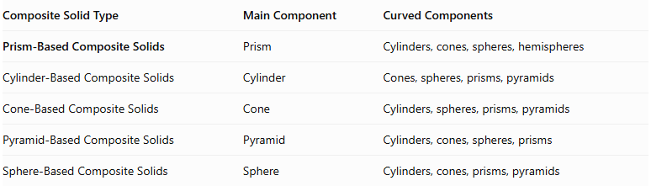
Composite Solid Type | Main Component | Curved Components
Prism-Based Composite Solids | Prism | Cylinders, cones, spheres, hemispheres
Cylinder-Based Composite Solids | Cylinder | Cones, spheres, prisms, pyramids
Cone-Based Composite Solids | Cone | Cylinders, spheres, prisms, pyramids
Pyramid-Based Composite Solids | Pyramid | Cylinders, cones, spheres, prisms
Sphere-Based Composite Solids | Sphere | Cylinders, cones, prisms, pyramids

Applications
# Source: AI Source: Provided by: [Data Path: Persons Table -> ID Column: 1, Name_En Column: Motasem Essam] -> From: [ChatGPT] on [7/25/2026]
- Architecture: Designing buildings and decorative structures that combine rectangular or polygonal foundations with curved components.
- Mechanical Engineering: Designing machine components with flat mounting surfaces and cylindrical or conical parts.
- Construction: Creating columns, supports, pillars, and structural elements.
- Manufacturing: Producing objects with polygonal bases and curved extensions.
- Product Design: Creating furniture, containers, decorative objects, and household products.
- Industrial Design: Developing components with mixed flat and curved external surfaces.
- CAD Modeling: Constructing complex three-dimensional models by joining different geometric solids.
- Education: Teaching composite volume, external surface area, and geometric combinations.

Key Points
# Source: AI Source: Provided by: [Data Path: Persons Table -> ID Column: 1, Name_En Column: Motasem Essam] -> From: [ChatGPT] on [7/25/2026]
- Prism-Based Composite Solids combine a prism with one or more curved solids.
- Common curved components include cylinders, cones, spheres, hemispheres, and frustums.
- The resulting solid contains both flat and curved external surfaces.
- The prism may have any polygonal base shape.
- Components may be attached to the top, bottom, sides, or multiple faces.
- The total volume is the sum of component volumes when there is no overlap.
- External surface area includes only exposed surfaces.
- Hidden joining surfaces must be excluded from the external surface-area calculation.
- Different curved-solid types can be combined with the same prism to create more complex structures.

Conclusion
# Source: AI Source: Provided by: [Data Path: Persons Table -> ID Column: 1, Name_En Column: Motasem Essam] -> From: [ChatGPT] on [7/25/2026]
Prism-Based Composite Solids with Flat and Curved Surfaces are three-dimensional structures formed by combining a prism with one or more curved solids, such as cylinders, cones, spheres, hemispheres, and frustums.
These solids combine polygonal flat faces with curved external surfaces, creating a wide variety of geometric structures.
Their mathematical analysis involves calculating the total volume of the components and determining the external surface area while excluding hidden joining surfaces. They are important in solid geometry, architecture, engineering, manufacturing, and three-dimensional modeling.

